**JENKINS INTEGRATION WITH SELENIUM PROJECT**

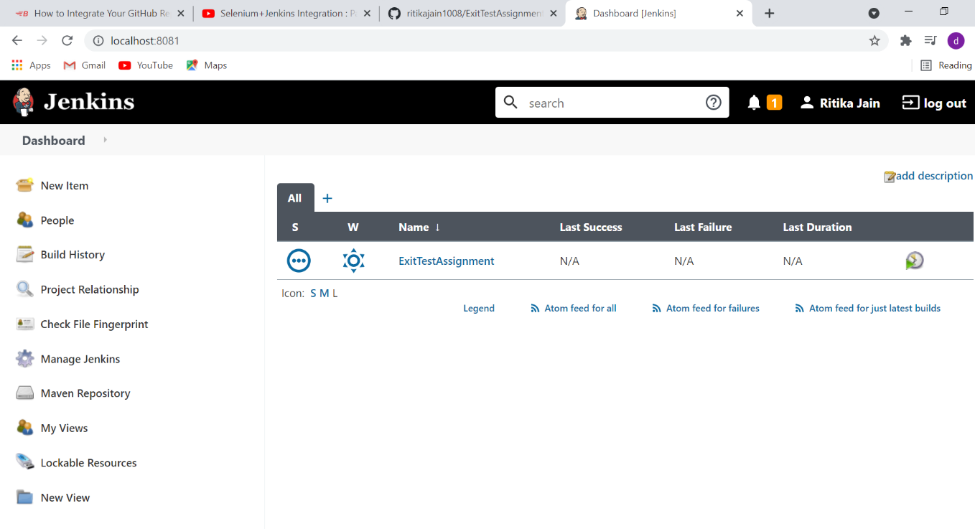

This is a ExitTestAssignment which is shown by running Jenkins on localhost port no 8081. Firstly the setup is to be done by giving location of the project. Then click on Build Now Option. Then this console output is generated as shown below:-

Then , Test result report will be generated as shown below:-

This is the test report generated where some testcases got failed & some got passed.